G. Rupa Manasa 13-12-2023

SQL Coding Assessment

1. **Querying Data by Using Joins and Subqueries**

**Joins**

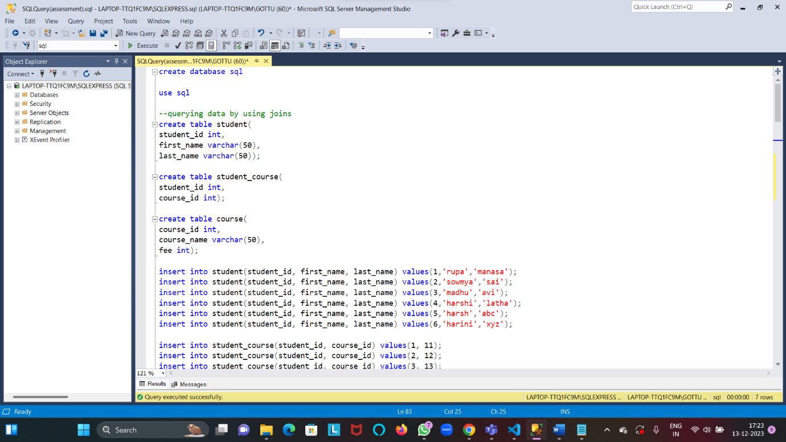

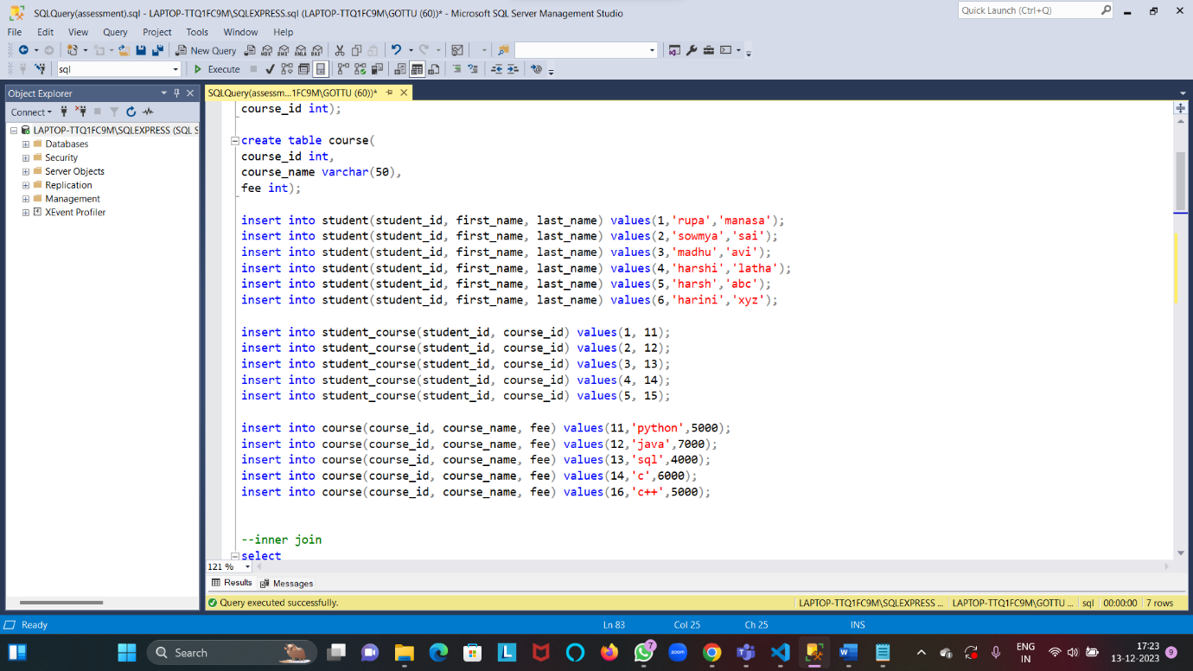

**Performing inner join**

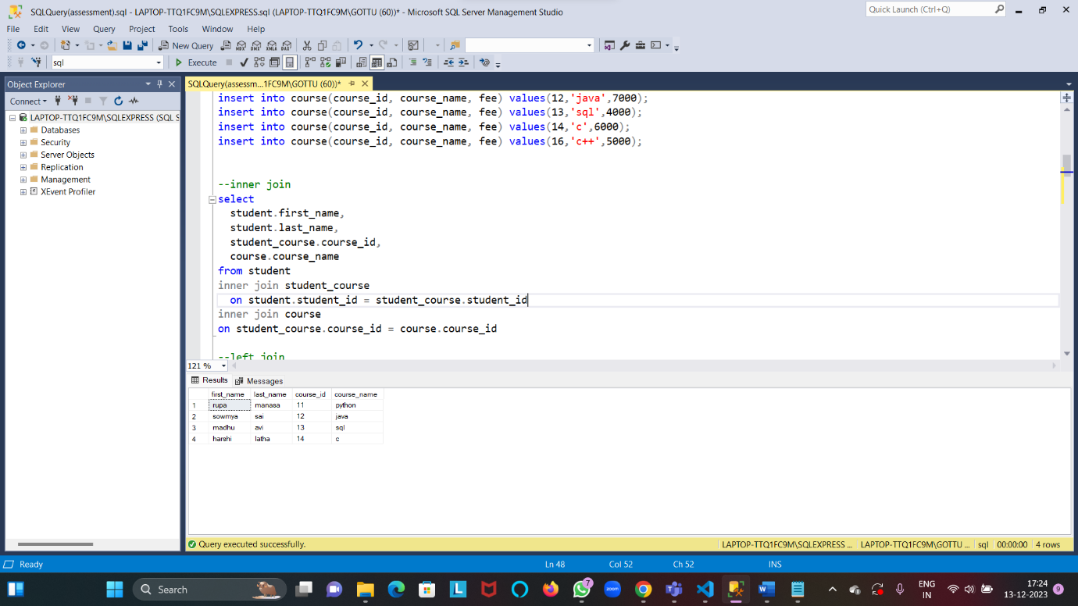

**Performing left join**

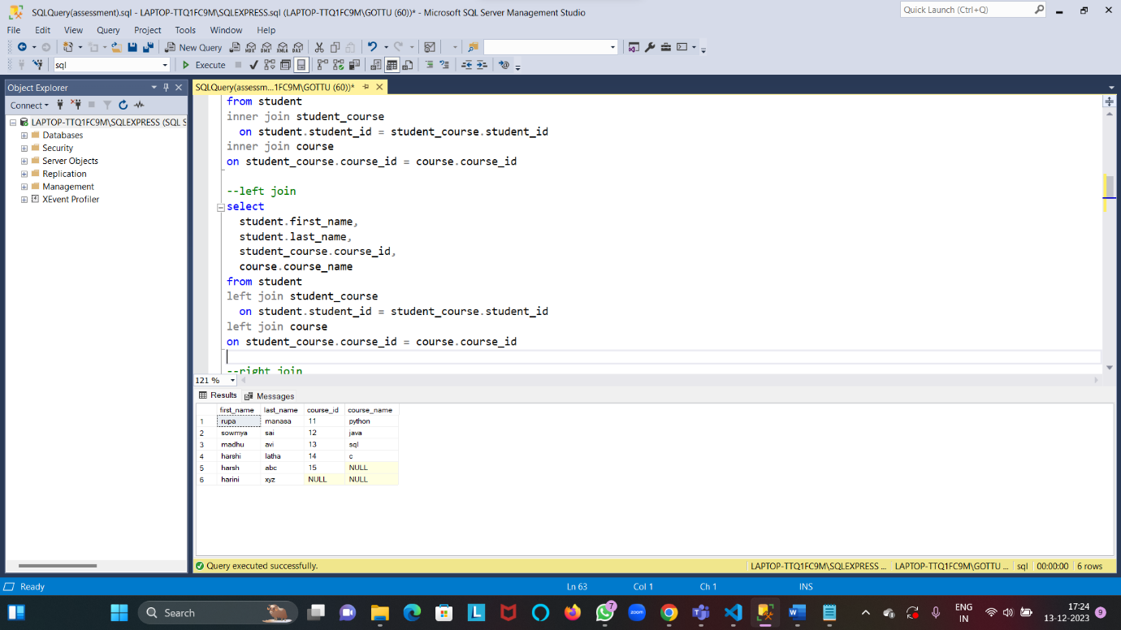

**Performing right join**

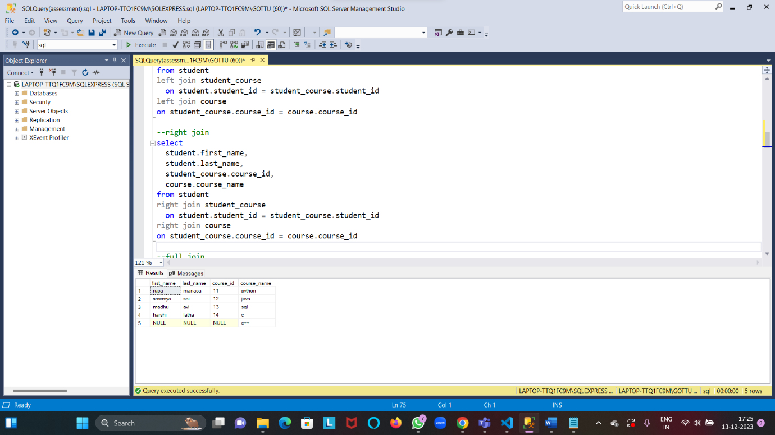

**Performing full join**

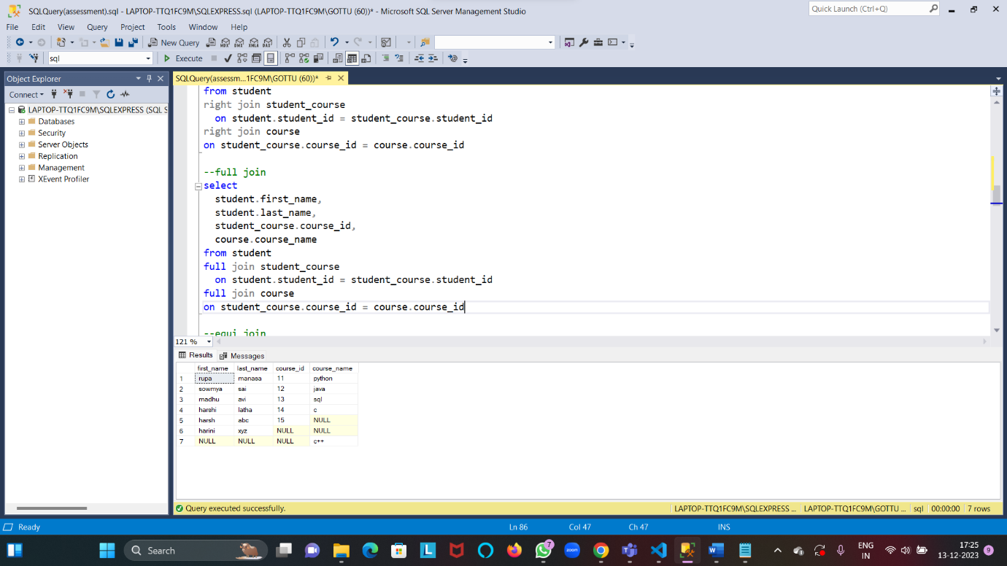

**Performing equi and non equi join**

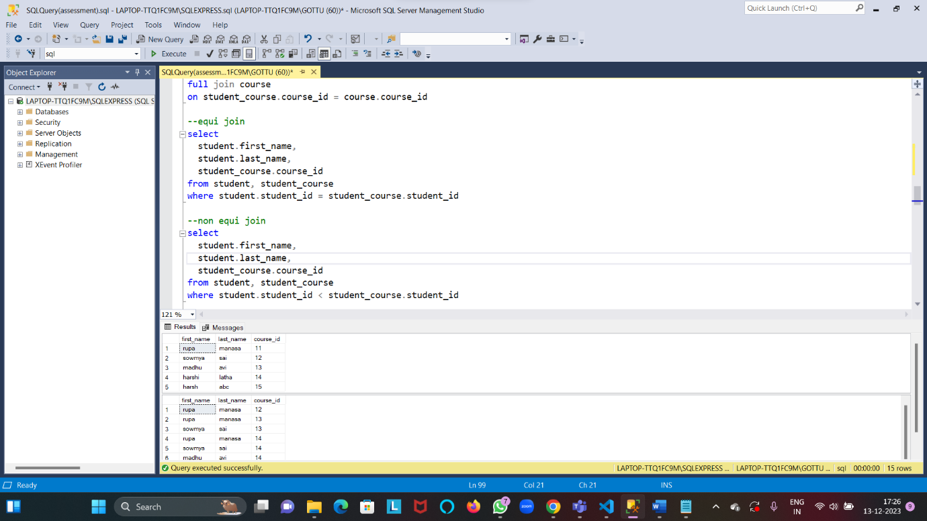

**Querying data by using sub queries**

**(using exists)**

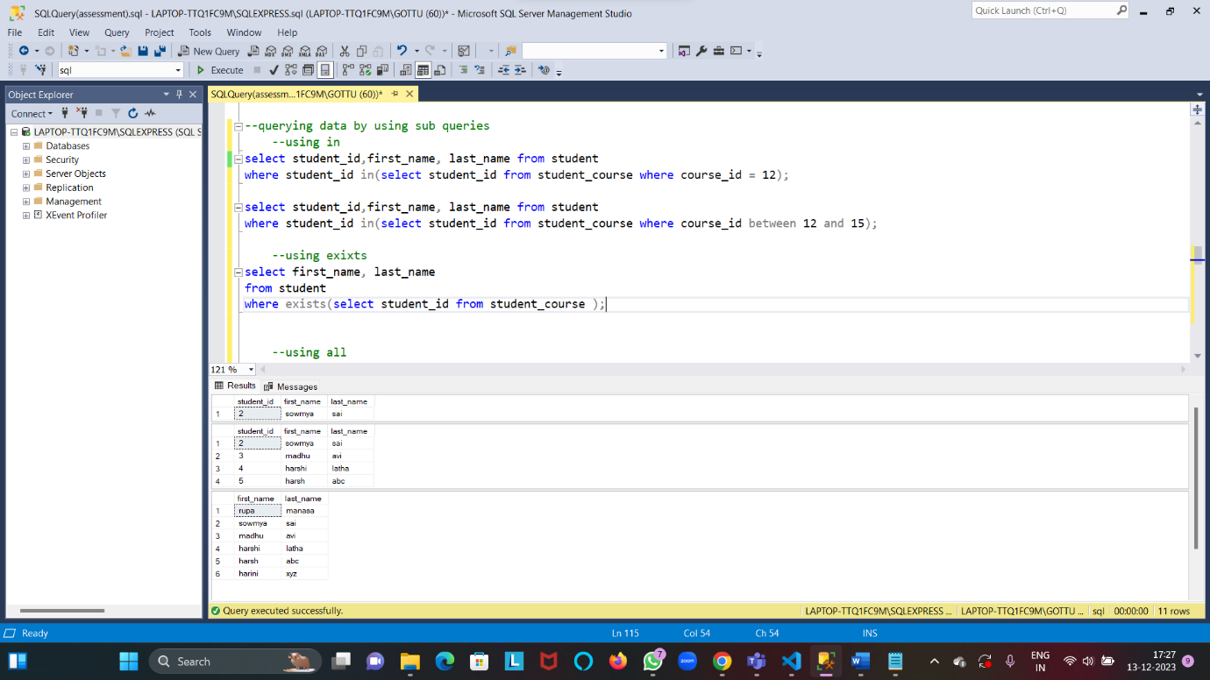

**Querying data by using sub queries(using all and any)**

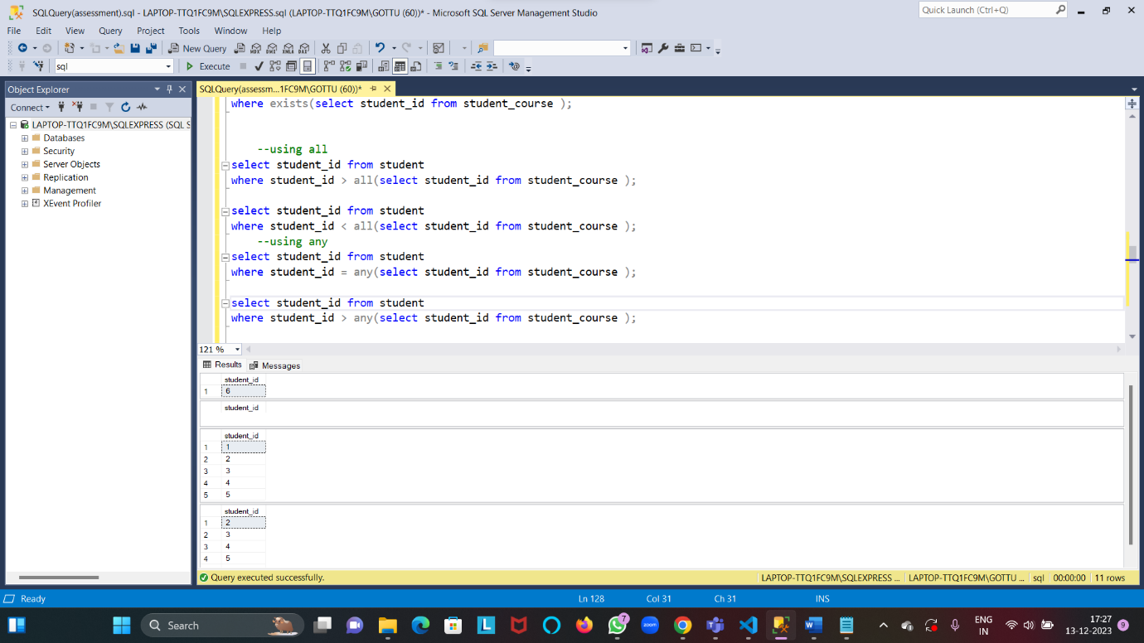

1. **Manipulate data by using sql commands using groupby and having clause.**

**Creating and inserting data into table**

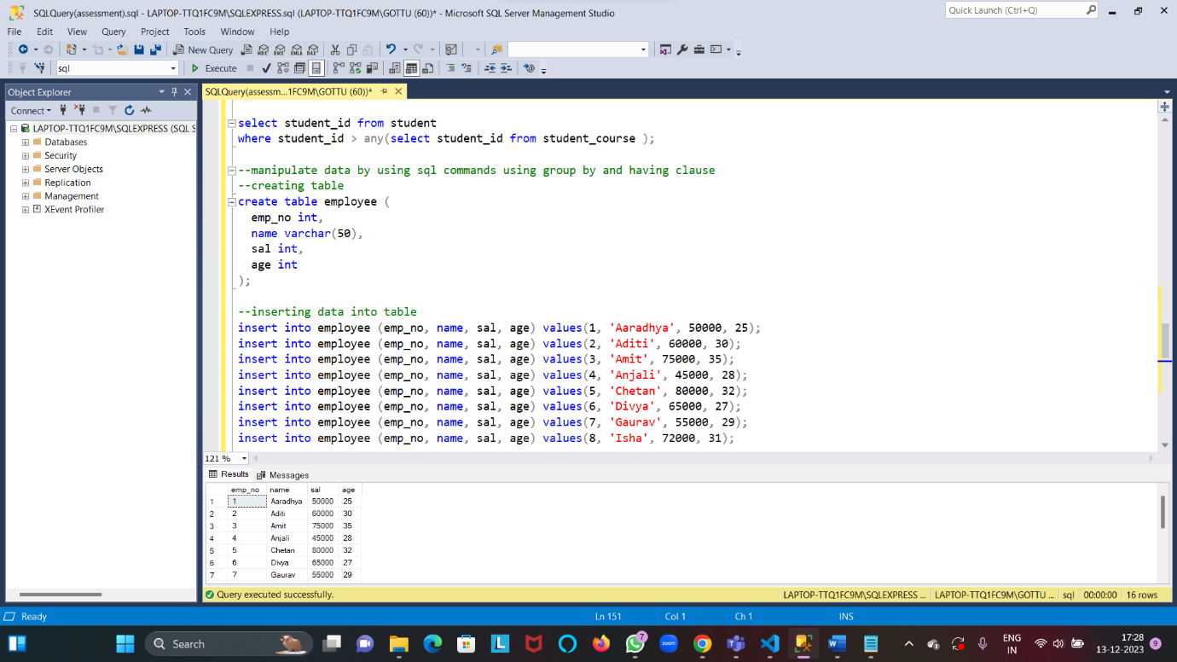

**Retrieving all data**

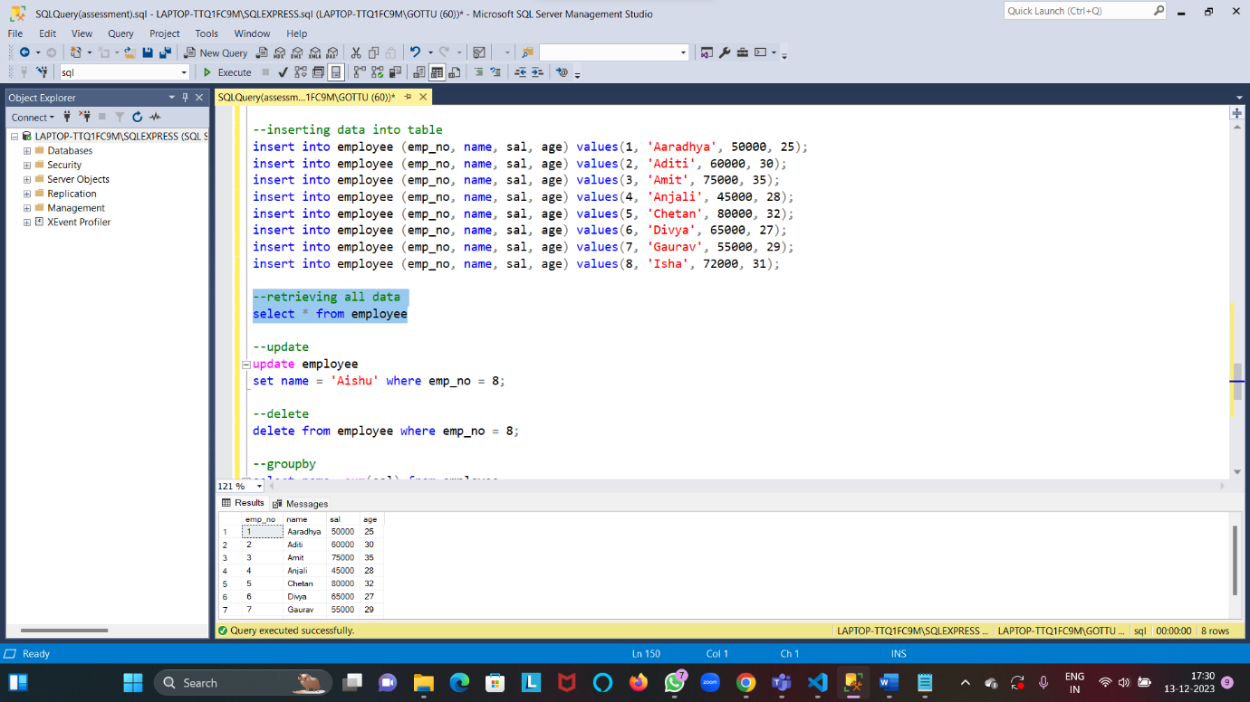

**Updating data**

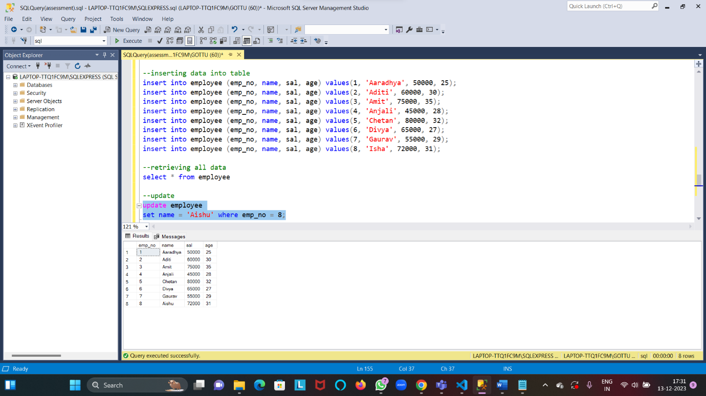

**Deleting the data**

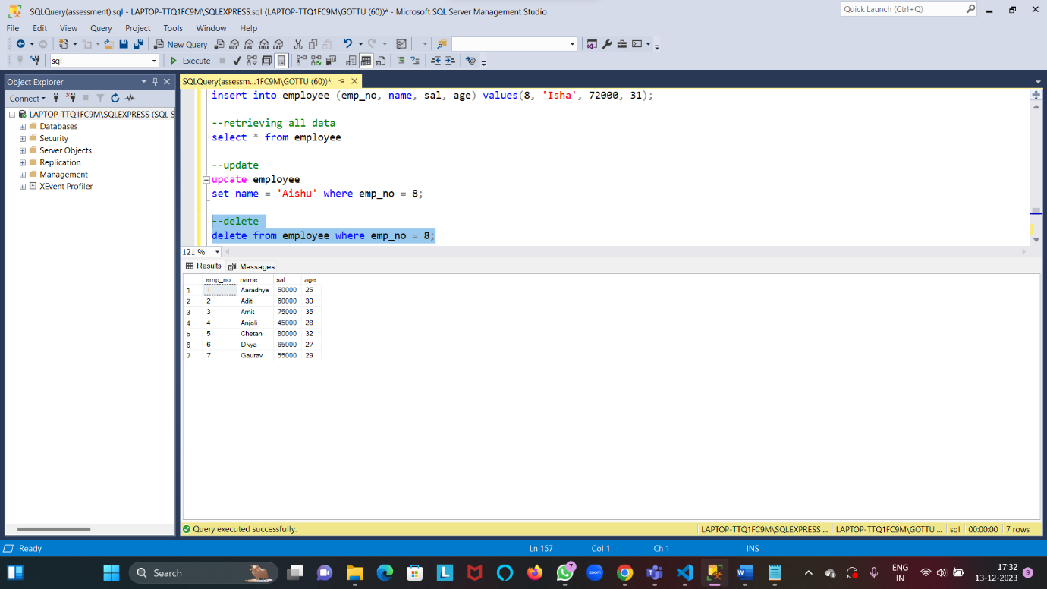

**Group by and having clause**

